IT Daily Support of Accounting
- Copy machine login Account
IP address: 172.17.7.226
Username: Admin
Password: Admin
Scanner to folder:
Setup the ip address for everyone
Check the login account from the copy machine(login with copier)
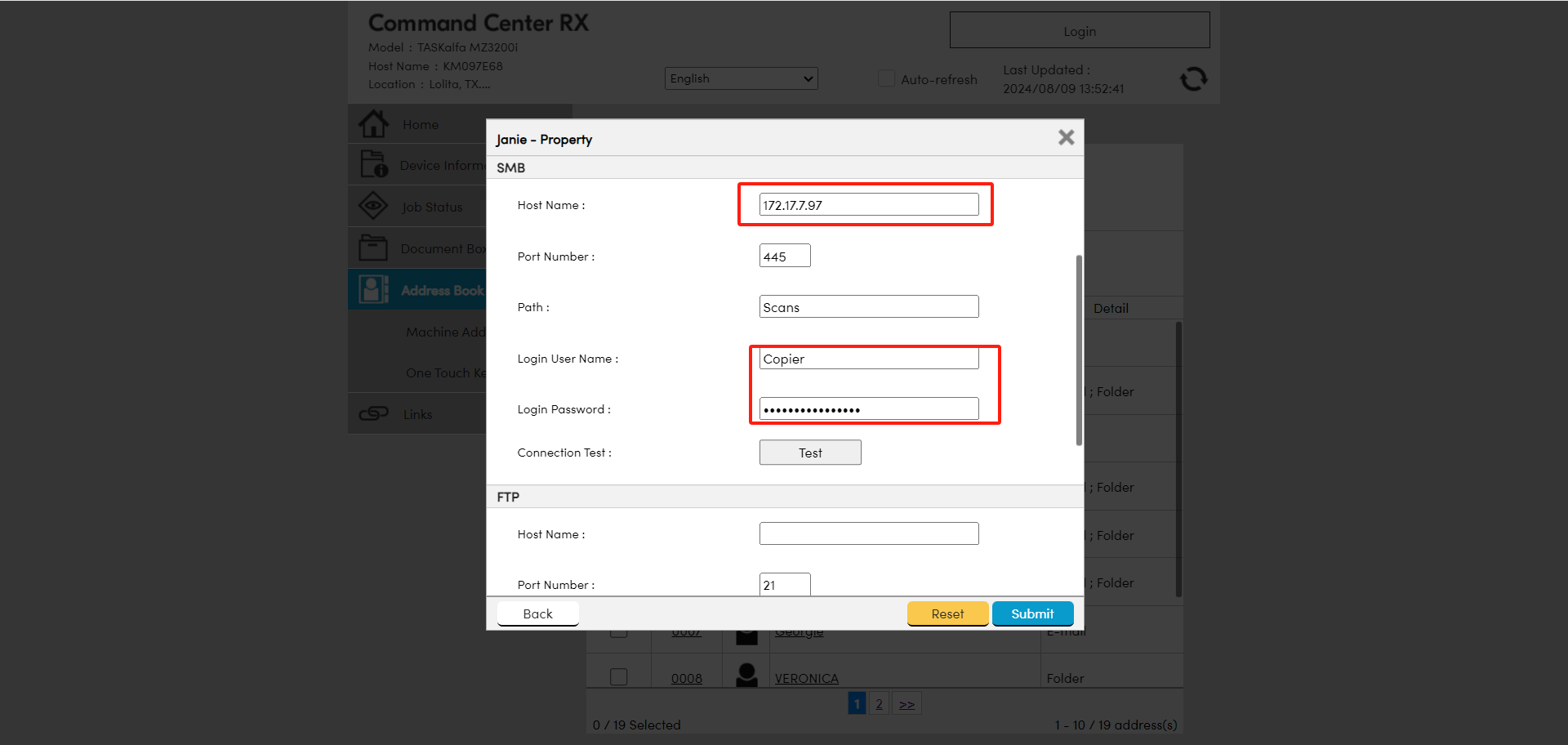
Login with the fuhq account(you need change the password, when the user was changed)
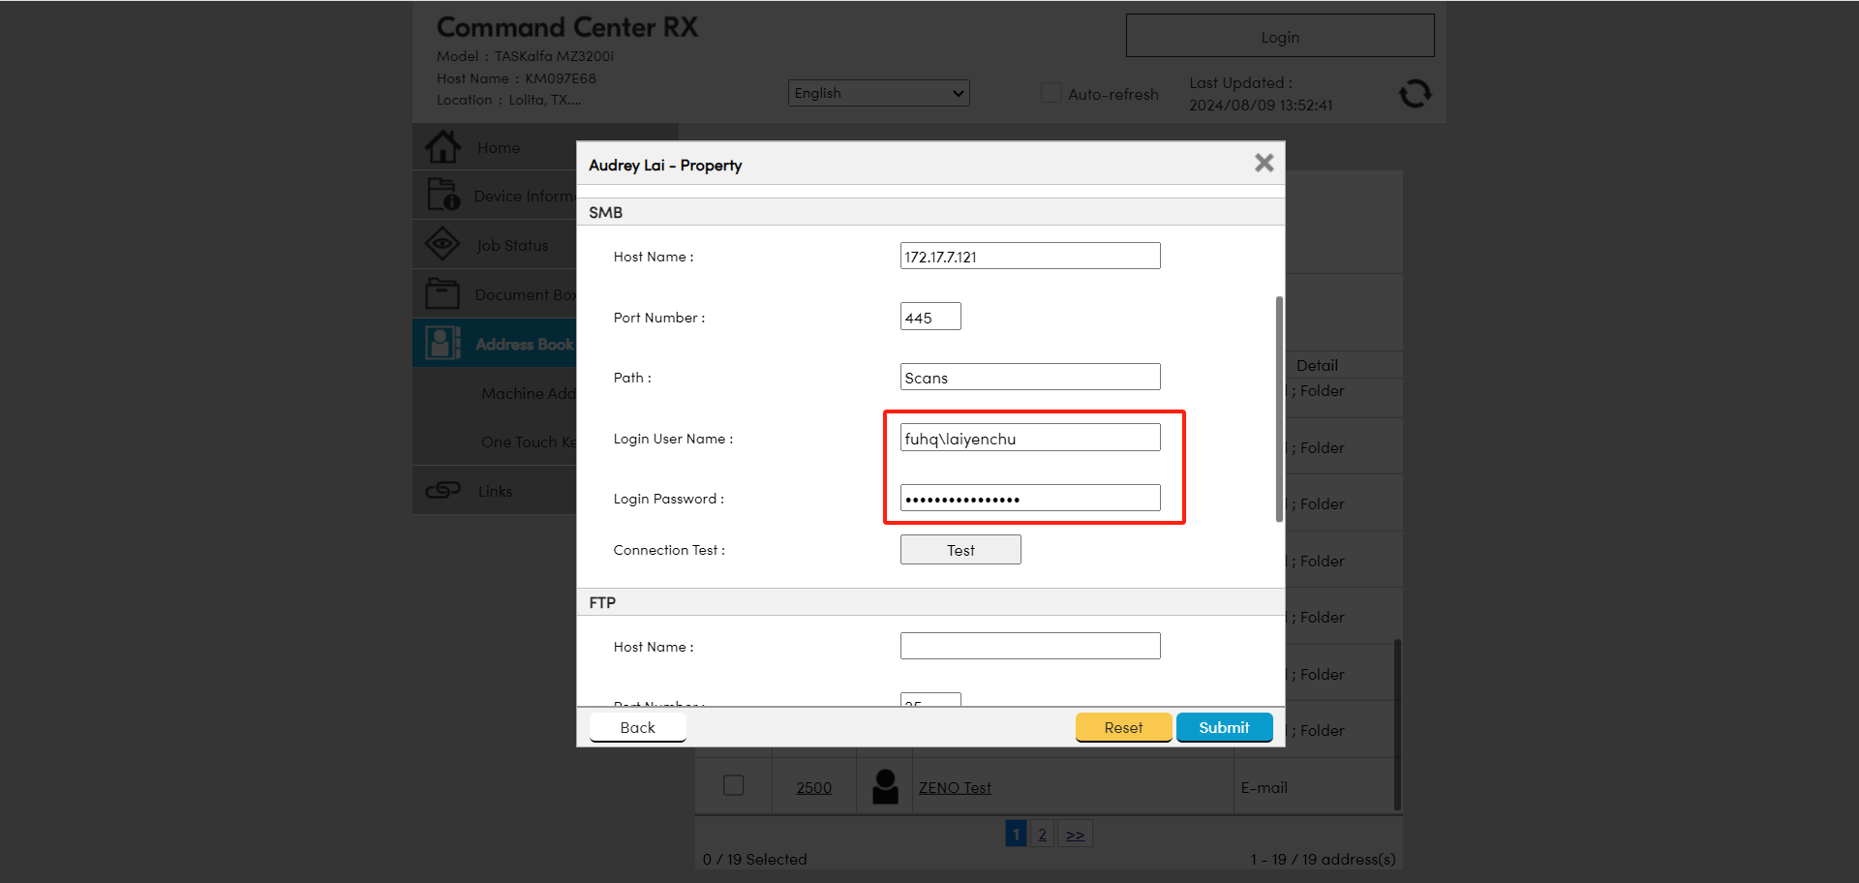

- Remote desktop connection from the windows
172.17.8.25
Domain admin account
Username: fuhq\leewenbin
Password: May2025!@#
We need changed primary DNS to 172.17.8.25, when we use the Remote Desktop Connection to access it.

After changing the login password, you can log in to the computer, but you cannot log in to Microsoft email account.( Synchronization has a 15-minute delay)
Current：
